EXPERIMENT 07
Component-Based Web Application using React JS
Course Outcome: CO4 – Understanding and implementing web application using React.
Aim: To develop a simple Smart Irrigation application using React JS, JSX, functional components, props, state and event handling.
Mrudul Bhagwat 16010125020 A1

Objectives
Create and run a basic React application using Node.js and npm.
Understand JSX as an XML-like syntax extension used inside JavaScript for describing React UI.
Develop reusable functional components.
Pass data between components using props.
Manage changing UI data using state and useState().
Handle user interaction using React event handlers.
Case Study: Smart Irrigation Advisory System. This experiment uses sample farm details and a button to change the displayed soil moisture.

Software Requirements
Node.js and npm
Visual Studio Code
Google Chrome or another modern browser
Terminal or Command Prompt

Theory

React and Existing HTML/CSS/JavaScript Knowledge
HTML gives a page its structure, CSS adds styles, and JavaScript adds actions. React lets us divide a page into small reusable components.

JSX and XML Correlation
JSX lets us write HTML-like tags inside JavaScript. We can display a JavaScript value inside curly braces { }.
const crop = "Sugarcane";
function App() { return <h1>{crop}</h1>; }
HTML: class="box" → JSX: className="box".
HTML onclick="..." → JSX onClick={...}.
JSX permits JavaScript expressions inside { }.
XML represents structured data using tags; JSX describes UI.
JSON represents data using key-value pairs and arrays.

Functional Components
A functional component is a JavaScript function that returns JSX. Here, FarmInfo displays the farm details.
function FarmInfo() {
return <h2>Farm Details</h2>;
}

Props
Props pass information from a parent component to a child component. In this example, App sends the farmer name, crop and plot to FarmInfo.
function FarmInfo(props) {
return <p>{props.farmer} - {props.crop}</p>;
}
<FarmInfo farmer="Ramesh Patil" crop="Sugarcane" />

State and Event Handling
State stores a value that can change. useState() stores the soil moisture. When the Add Water button is clicked, the value changes and React updates the page.
const [moisture, setMoisture] = useState(40);
<button onClick={() => setMoisture(moisture + 5)}>
Add Water
</button>

Problem Statement
Develop a simple Smart Irrigation application. Display farmer name, crop, Plot ID and soil moisture using a FarmInfo component. Pass the farm details using props. Use state and an Add Water button to increase the sample moisture by 5 percentage points. Show a simple demo message based on the moisture value.

Tasks to be Completed:
- Verify Node.js and npm using node -v and npm -v.
- Create a React application named react-irrigation using Vite.
- Run the application and identify the public and src folders.
- Modify App.jsx to show the KisanSaathi heading.
- Create FarmInfo.jsx as a functional component.
- Pass farmer, crop, plot and initialMoisture from App.jsx using props.
- Display the received information using JSX.
- Add a soil moisture state variable using useState().
- Create an Add Water button using onClick.
- Apply basic CSS using App.css.
- Run and test the application in the browser.
- Capture the output before and after clicking the button.

Procedure
1. Open a terminal and go to the practical folder.
2. Run: npm create vite@latest react-irrigation -- --template react
3. Run: cd react-irrigation, then run npm install.
4. Run npm run dev and open the local URL shown in the terminal.
5. Open the project in VS Code.
6. Create FarmInfo.jsx inside src.
7. Write the FarmInfo component and export it.
8. Import FarmInfo into App.jsx and pass the farm details as props.
9. Add useState and the addWater function for the button.
10. Save the files and click Add Water to check the updated moisture value.

Project Structure
GitHub Repository :https://github.com/mrudul2505/AI-based-Smart-Irrigation-Advisory-Kisan-Sathi-
The application uses two components: App and FarmInfo.
react-irrigation/
public/
src/
App.jsx
FarmInfo.jsx
main.jsx
App.css
package.json
index.html
vite.config.js

Program
// src/FarmInfo.jsx
import { useState } from 'react';
function FarmInfo(props) {
const [moisture, setMoisture] = useState(props.initialMoisture);
function addWater() {
if (moisture < 100) {
setMoisture(moisture + 5);
}
}
return (
<div className="card">
<h2>Farm Details</h2>
<p>Farmer: {props.farmer}</p>
<p>Crop: {props.crop}</p>
<p>Plot ID: {props.plot}</p>
<p>Soil Moisture: {moisture}%</p>
<p>Demo advice: {moisture < 60
? 'Irrigation is needed.' : 'Soil has enough moisture.'}</p>
<button onClick={addWater} disabled={moisture === 100}>
Add Water
</button>
</div>
);
}
export default FarmInfo;
// src/App.jsx
import FarmInfo from './FarmInfo.jsx';
import './App.css';
function App() {
return (
<div>
<h1>KisanSaathi</h1>
<h2>Smart Irrigation Demo</h2>
<FarmInfo farmer="Ramesh Patil" crop="Sugarcane"
plot="PLOT-A" initialMoisture={40} />
<p>Sample values for a React lab experiment.</p>
</div>
);
}
export default App;
/* src/App.css */
body {
font-family: Arial, sans-serif;
text-align: center;
margin: 30px;
}
h1 {
color: green;
}
.card {
border: 1px solid gray;
padding: 20px;
width: 300px;
margin: 20px auto;
}
button {
padding: 8px 15px;
font-size: 16px;
}
// src/main.jsx
import { createRoot } from 'react-dom/client';
import App from './App.jsx';
createRoot(document.getElementById('root')).render(<App />);

Output
The page displays sample farm details and a starting moisture of 40%. One click on Add Water changes it to 45%. After four clicks it becomes 60%, and the demo advice changes. The button is disabled at 100%. These screenshots were taken from the local React app at http://127.0.0.1:5173/.
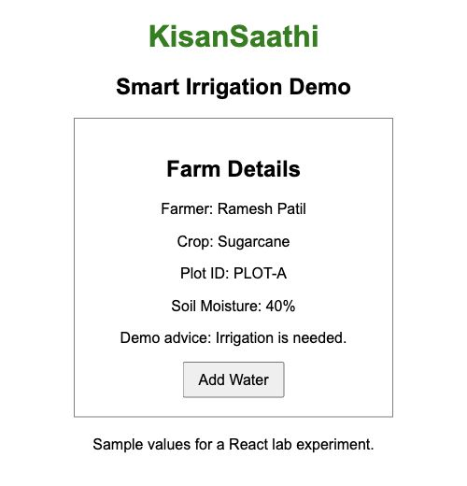  Before clicking: moisture 40%. | 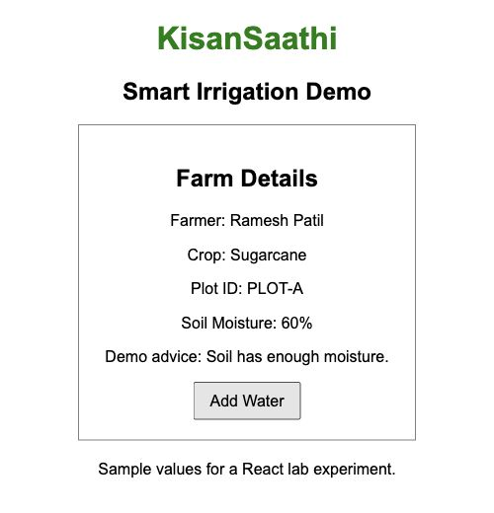  After four clicks: moisture 60%.

Result
I created a simple React application for the Smart Irrigation case study. I used props to display farm details and useState to update the moisture value when the button was clicked. This example uses sample values and a classroom rule. It does not read a real sensor or operate a water pump.

Post Lab Questions
- How is JSX different from HTML?
Answer: JSX is written inside JavaScript and can display values using { }. It uses names such as className and onClick. HTML is the markup used directly in a web page.
- What is a functional component?
Answer: A functional component is a JavaScript function that returns JSX. FarmInfo is a functional component in this application.
- Why is className used instead of class in JSX?
Answer: React uses className to set the HTML class of an element. For example, className="card" applies the card styles from App.css.
- How is React different from direct DOM manipulation?
Answer: With direct DOM manipulation, we change elements ourselves using methods such as getElementById(). In React, we update state and React updates the displayed content.

